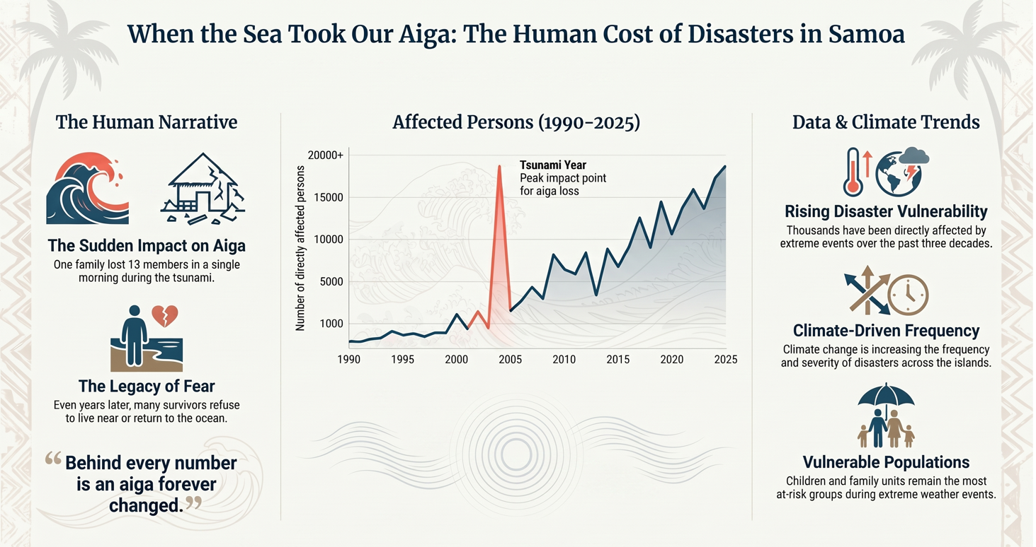

Source: Pacific Data Hub — Number of directly affected persons attributed to disasters dataset (2026).

